Record of Observation or Review of Teaching Practice

Session/artefact to be observed/reviewed: Summative assessment feedback

Size of student group: 30

Observer: Rachel Marsden

Observee: Stephanie Cooper

Note: This record is solely for exchanging developmental feedback between colleagues. Its reflective aspect informs PgCert and Fellowship assessment, but it is not an official evaluation of teaching and is not intended for other internal or legal applications such as probation or disciplinary action.

Part One
Observee to complete in brief and send to observer prior to the observation or review:

What is the context of this session/artefact within the curriculum?

Feedback, Unit 9, final year Collection Proposal

How long have you been working with this group and in what capacity?

I have worked with this group for 2 years, as 2nd year and final year tutor/pathway leader

What are the intended or expected learning outcomes?

- Enquiry
Engagement in practice informed by critical analysis and evaluation of diverse, complex concepts and ideas

- Knowledge
Critical analysis of a range of practical theoretical and/or technical knowledge(s)
- Process
Experiment and evaluate methods, results, and their implications

- Communication
Demonstrating clarity and depth. synthesis of diverse intentions, contexts and arguments appropriate to your audiences

- Realisation
Meeting appropriate standards of professional production

What are the anticipated outputs (anything students will make/do)?

They create a portfolio document of a proposal which leads to the realisation of their fashion collection

Are there potential difficulties or specific areas of concern?
none

How will students be informed of the observation/review?
Assessment feedback online portal/Moodle

What would you particularly like feedback on?
The clarity and depth of the feedback.

How will feedback be exchanged?

Part Two

Observer to note down observations, suggestions and questions:

Thank you for sending summative feedback over for review Stephanie. Note, I looked at all the samples of summative feedback provided. Below, I have provided some reflections, questions and signposts – do not feel the need to respond to all of this in Part Three of the form, rather shared for future consideration.

On first look, the feedback you provide is student-centred (clearly positioning the ‘you’), focused and detailed – approximately 350-400 words for each student – where I wonder if the content could be broken down into easier to read chunks perhaps via some bullet points or paragraph / section breaks? A first question, is this general feedback you provide in addition to feedback as related to the assessment criteria and learning outcomes (LOs)? Or the main / overall feedback? There is an expectation as part of ‘Inclusive Marking’ at UAL, under communicating feedback, to “Set comments explicitly against the learning outcomes and relevant assessment criteria.” I can see that through your feedback you begin to make some connection to the LOs (say process and communication are regularly referenced) – as such the relationship to criteria and LOs could be made more explicit. You also regularly speak to research, though again it isn’t reflected in the assessment criteria and LOs – wondering how research might be included here? I can also see the LOs are broadly worded rather than specifically framed in the context of the Unit 9 / Collection Proposal. You might have inherited these LOs from a colleague / unit / course so there might be an opportunity to develop these in the future (I know that’s often the case for me that I inherit LOs!).

In turn, do you use the assessment feedback online tool to upload and provide feedback? Or are the criteria and overall grades with feedback communicated in a different way? Say by email? Do you offer written and / or verbal opportunities for students to engage with / further digest their feedback? Perhaps you provide support via tutorials? I don’t have insight into this from what you’ve shared, but it is worth considering the overall “journeying” with assessment and feedback for students.

It’s brilliant to see the range of contexts, methods, action verbs, materials and even emotive language used in the feedback. Also, you confidently use celebratory and empowering language – ‘epic’, ‘exceptional’, ‘inspiring’, ‘well’, ‘strong’, ‘strength’, ‘good’, ‘effective’ – FANTASTIC to read! One suggestion - regardless of awarding grade (and more so for lower grades), I would provide some prompts or questions for how the work can be improved or move forward – as such, more possibility for feed-forward (even if it’s at the end of a year or qualification). You allude to this a little in the B graded feedback, but I feel this could go further to justify why a student has been awarded that grade banding.

Another helpful tool I often use to reflect upon writing feedback is a word cloud generator to look at the language used and / or being leaned upon. In seeing your summative feedback visualised and reordered below, what do you identify? In turn does the word cloud highlight the types of positive and more critical, feedforward language in use? I feel this exemplifies much of what I’ve said in the previous paragraph….making me think about authentic assessment and feedback as discussed in one of the TPP workshops.

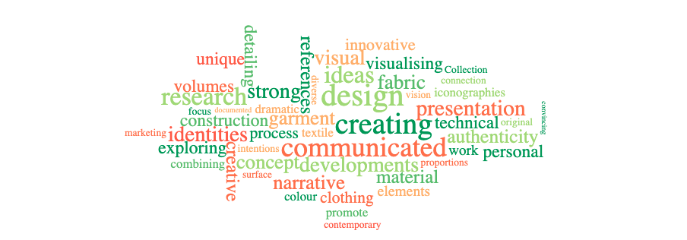

Another suggested activity /exercise might be to review feedback with colleagues; a team exercise to look at each other’s feedback. We often do this in the Academic Practice team to both think about the parity, effectiveness and equity of feedback, alongside an opportunity to learn with different styles and approaches to feedback. In turn, does your team have any collective or “guiding principles” – see QAA link – to assessment and feedback? Just a suggestion. Thanks again for allowing me into this space of feedback Stephanie.

Some helpful links documents to help guide your approach to assessment and feedback include:

- UAL Assessment and Feedback: https://www.arts.ac.uk/about-ual/teaching-and-learning-exchange/resources/assessment-and-feedback
- ‘Compassionate feedback prompts’ document on Canvas: https://canvas.arts.ac.uk/documents/sppreview/73b9e100-e4db-452f-8109-0600aff48b96
- And wider work at UAL on ‘Compassionate feedback’: https://canvas.arts.ac.uk/News/209366/interrogating-spaces-episode-compassionate-feedback
- AdvanceHE Assessment and Feedback in Higher Education: https://www.advance-he.ac.uk/teaching-and-learning/assessment-and-feedback-higher-education
- AdvanceHE’s recent work on Five dimensions of feedback for implementing authentic assessment: https://www.advance-he.ac.uk/news-and-views/five-dimensions-feedback-implementing-authentic-assessment
- UK Quality Code, Advice and Guidance: Assessment (QAA) https://www.qaa.ac.uk/the-quality-code/advice-and-guidance/assessment (this includes guiding principles).

Part Three

Observee to reflect on the observer’s comments and describe how they will act on the feedback exchanged:

It’s really insightful to have the feedback so well explored and the comments raised about making the wording more clearly related to the different Learning Outcomes is something I will closely consider and put into practice for the future. I do consider all the Learning Outcomes when writing feedback but I can see how it would be easier to follow by students if it was formatted to be more clearly linked. Also the suggestion of breaking the wording into more easier to read chunks is a great piece of advice which I will definitely act on.

I use the assessment feedback tool to upload the feedback and mark the grading, but there are always follow up tutorials to explain the grading and the feedback and to offer further advice. In addition, the feedback is usually written following a group crit or a presentation where verbal feedback from all tutors on the project is given, so students will have already had comments and suggestions made by tutors. The unit 9 presentations are not conducted with verbal feedback, as final year students have weekly tutorials where they are given advice on their work and very clear guidelines on what to submit and how they are progressing with producing the outcome, so I write more lengthy feedback notes for unit 9 in the absence of any verbal feedback at the presentations. I will put into practice the suggestions made when writing the unit 11 feedback at the end of Summer term, which also will not have a formal crit presentation with verbal feedback.

For 2nd year unit 7 feedback which will be written after their presentations on 15th March, I will format the wording to reflect the suggestions made about clarity in referencing comments to Learning Outcomes and also in creating a more accessible format in breaking up the wording into easier to read chunks. I’ll take on the comments positively and make some advancements in the formatting and in the clarity. It’s good to see that the range of contexts and wording provide a positive reaction. I will work on continuing to develop encouragement even when commenting on the lower grade outcomes.
The links provided will be great to explore in terms of improving and further developing feedback techniques.

